Unit 3: Atomic Theory and the Nuclear Atom

Free Response Review #1

Directions: The suggested time is about 15 minutes for answering the constructed response section of the chemistry test. The parts within a question may not have equal weight. For calculations, show all your work in the spaces provided after each part. Pay particular attention to the proper use of units. Be sure your final answer is rounded to the correct number of significant figures. Make sure your work is legible. Illegible work will receive a grade of zero.

Question 1 [3 POINTS]
A generalized diagram for the electromagnetic radiation spectrum is pictured below.

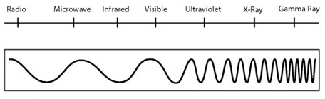
__Low_ Energy
__Low__ frequency
_High__ wavelength
- Using the box above, label the Radio end of the spectrum as high or low energy, high or low frequency, and long or short wavelength. [1 POINT]

- Is the relationship between frequency and wavelength directly or inversely proportional? Explain, based on the nature of the speed of light, c, why this is the case. [2 POINTS]
Frequency and wavelength= inversely
Energy and Wavelength =Inversely
Energy and Frequency= Directly
Question 2 [7 POINTS]
A. Consider a neutral, ground state atom of scandium.
  - Write the complete orbital electron configuration for this atom. [1 POINT]

  - Write the complete standard electron configuration for this atom. [1 POINT]

1s²2s²2p⁶3s²3p⁶4s²3d¹

  - Write a complete set of quantum numbers for EACH of the valence electrons in this atom. [2 POINTS]

Scandium has 2 valence electrons. Both are in the 4s.

4,0,0,+1/2
4,0,0,-1/2

- One possible excitation of the scandium atom moves one of its 4s electrons into the 3d orbital.
- Write the complete orbital electron configuration for this excited atom. [1 POINT]

- Write the noble gas electron configuration for this excited atom. [1 POINT]
[Ar]4s¹3d²

- Write a complete set of quantum numbers describing the EXCITED electron in this scandium atom. [1 POINT].

3,2,-1,+1/2

