VSEPR
Unit 5 Page 21

Learning Target:
I can predict molecular structure for molecules with linear, trigonal planar, or tetrahedral electron pair geometries using Valence Shell Electron Pair Repulsion theory

Criteria for Success:
I can explain VSEPR theory
I can predict the electron geometry or molecular geometry of a molecule using VSEPR theory for linear, trigonal planar, or tetrahedral electron pair geometries.
Notes
VSEPR Theory
- V________ S_______ E_________ P_______ R________ (VSEPR) theory is a model used to predict the ____________of individual molecules from the number of electron pairs surrounding their central atoms.
- The premise of VSEPR is that the _________________ surrounding an atom tend to repel each other, and will therefore adopt an arrangement that_______________ this repulsion. This will determine the ________ of the molecule.
- The________ __________ and _______ _______ will arrange themselves as far as possible from each other.
- _______ _________ repel themselves more than bonding pairs.
- __________ and _________ bonds are treated as one pair or region.

- The "______ ___________" of electron counting is commonly used when applying the VSEPR theory.
- The A represents the _________ ________ and always has an implied subscript one.
- The X represents the number of ____________ that are bonded to the central atom.
- The E represents the number of _______ _______ electrons surrounding the central atom.
- Based on the steric number and distribution of X's(_______) and E's(_________ __________), VSEPR theory predicts the _________ of the molecules.

Geometry of Molecules
- 1. _________ ___________ is the geometry of the molecules describes the arrangement of _______ the atoms and lone pair electrons around the central atom.
2. _____________ ___________ describes only the___________ around the central atom.

Molecule Type | Shape^{[10]} | Electron arrangement^{†[10]} | Geometry^{‡[10]} | Examples
AX₂E₀ | Linear |  | 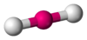 | BeCl₂, HgCl₂, CO₂
AX₂E₁ | Bent | 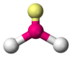 | 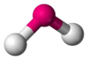 | SO₂ O₃, CCl₂
AX₃E₀ | Trigonal planar | 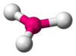 | 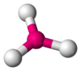 | BF₃, SO₃
AX₃E₁ | Trigonal pyramidal | 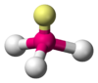 | 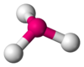 | NH₃, PCl₃
AX₄E₀ | Tetrahedral | 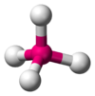 | 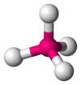 | CH₄, TiCl₄, XeO₄
AX₄E₂ | Square planar | 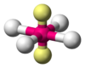 | 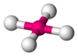 | XeF₄
AX₅E₀ | Trigonal bipyramidal | 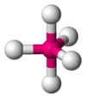 |  | PCl₅
AX₆E₀ | Octahedral | 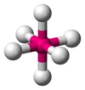 | 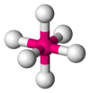 | SF₆, WCl₆

