Unit 2: Atomic Theory, the Nuclear Atom and the Mole

Free Response Review
Directions: The suggested time is about 15 minutes for answering the constructed response section of the chemistry test. The parts within a question may not have equal weight. For calculations, show all your work in the spaces provided after each part. Pay particular attention to the proper use of units. Be sure your final answer is rounded to the correct number of significant figures. Make sure your work is legible. Illegible work will receive a grade of zero.
Question 1 [10 POINTS]
A student compares some models of the atom. These models are listed in the table below in order of development from top to bottom.
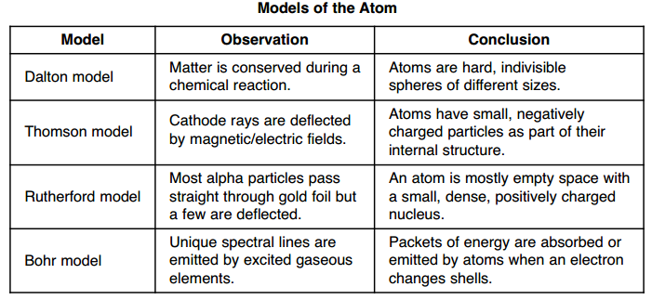
- State the model that first included electrons as subatomic particles. [1 POINT]

Thomson was the first to say that atoms could be subdivided and that they must contain a negative particle called the electron

- State one conclusion about the internal structure of the atom that resulted from the gold foil experiment. [1 POINT]

Rutherford was able to conclude from his gold foil experiment that atoms must contain a very small, dense nucleus and that the atom is mostly empty space

- Using the conclusion from the Rutherford model, identify the charged subatomic particle that is located in the nucleus. [1 POINT]

The nucleus is positive so it must contain the proton

- State one way in which the Bohr model agrees with the Thomson model.

The atoms contain electrons

The student continued to investigate Dalton and his original postulates of atomic theory. One of the concepts that she explored was isotopes. Answer the questions related to isotopes and atomic theory that follow.
Some isotopes of potassium are K-39, K-40 and K-41. The natural abundance and the atomic mass for the naturally occurring isotopes of potassium are shown in the table below.
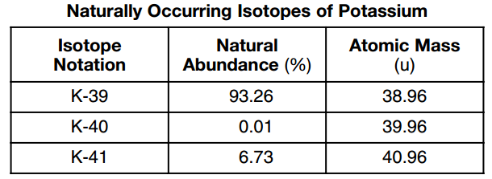
- List one of the postulates from Dalton’s atomic theory that is no longer true due to the discovery of isotopes. Explain in terms of subatomic particles. [2 POINT]

That all atoms of the same element are identical. We now know that 2 atoms of the same element can have a different number of neutrons.

- Show a numerical setup and calculate the average atomic mass of potassium. [2 POINTS]

38.96 x .9326= 36.334
39.96 x .0001= .003996
40.96 x .0673= + 2.757
39.095 amu

- Show a numerical setup using dimensional analysis and calculate the number of potassium atoms in a 59.2 g sample of potassium. [2 POINTS]

59.2gx$\frac{1mol}{39.095g}$x$\frac{6.02x10^{23}atoms}{1mol}$=9.12x10²³atoms K

