Unit 4 Review
What is electronegativity?

What is atomic radius?

What is ionization energy?

Draw arrows on the periodic table that shows these trends
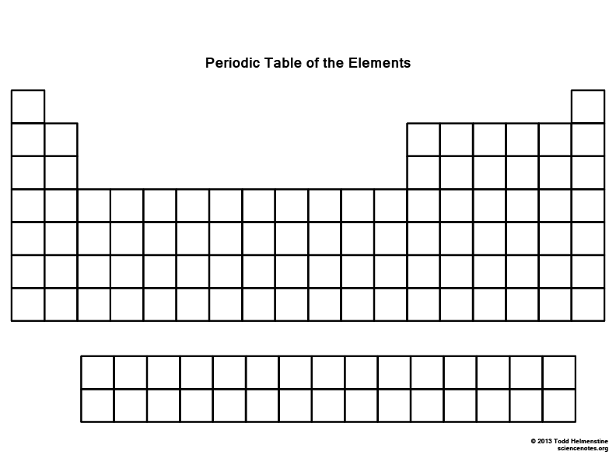
Write the effective nuclear charge for the following: Li Be B C N O F Ne

Write the effective nuclear charge for the following: Na Mg Al Si P S Cl Ar

From decrease to increase, describe how electronegativity trends on the periodic table. Why does it trend this way?

From decrease to increase, describe how atomic radius trends on the periodic table. Why does it trend this way?

From decrease to increase, describe how ionization energy trends on the periodic table. Why does it trend this way?

How many valence electrons does an atom with an atomic of 15 have?

What charge does an alkali metal form? Alkaline earth metal? Halogen? Nobel gas?

Are cations larger or smaller than their neutral atom? Are anions larger or smaller than there neutral atom?

19. Which electron configuration represents the element with the largest ionization energy?

A | 1s²2s²2p² | C | 1s²2s²2p⁴
B | 1s²2s²2p⁵ | D | 1s²2s²2p³

Why does B have a lower ionization energy than Be? Why does O have a lower ionization energy than N?

